TASK-4

Implement conflict resolution when multiple users are updating the trunk (or master) in such a way that it results into a conflict with the branch’s modification.

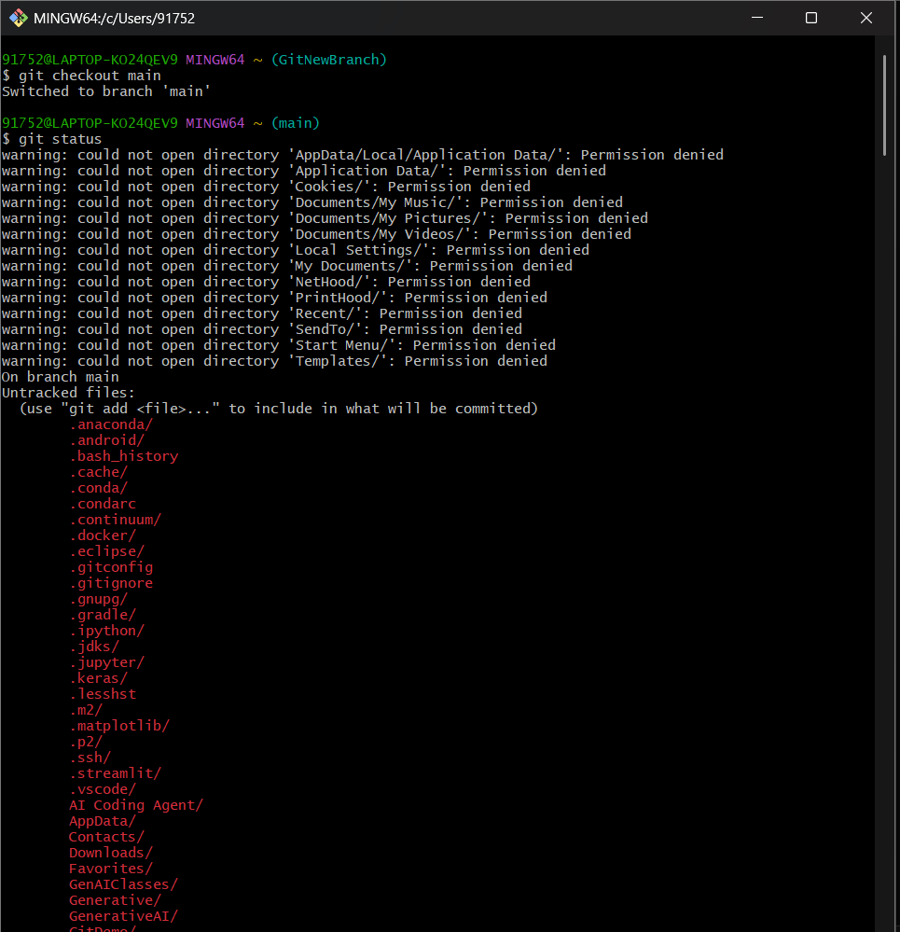

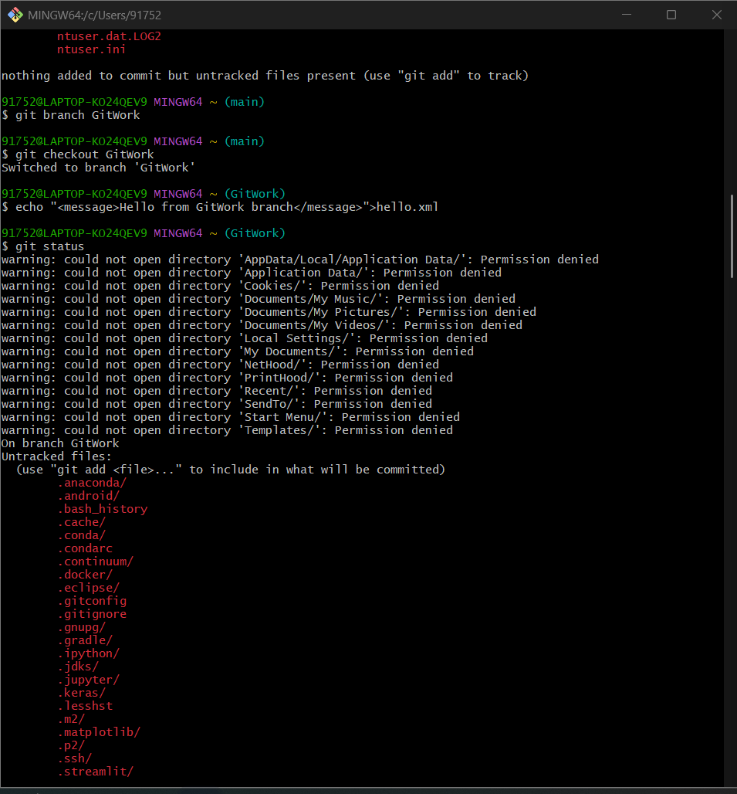

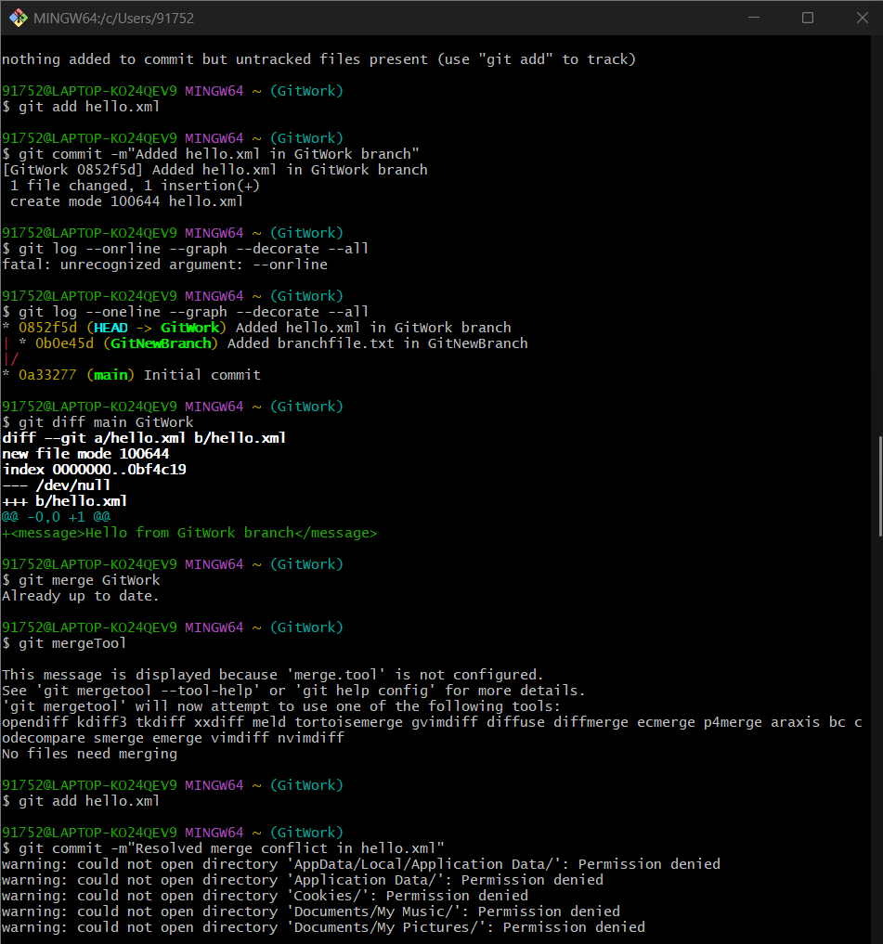

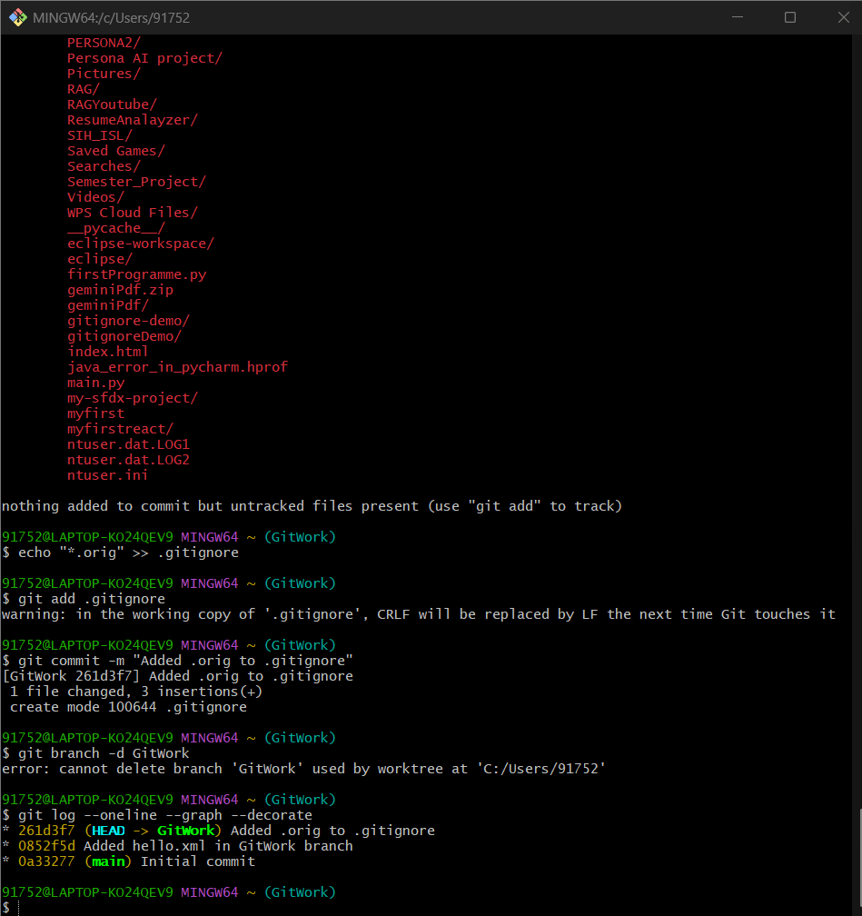

Step-1 **Initialize repo and make first commit**

git init

echo "First commit file" > readme.txt

git add readme.txt

git commit -m "Initial commit"

Step-2 Create and list branches

git branch GitNewBranch

git branch

Step-3  **Switch to new branch and add changes**

**git checkout GitNewBranch**

**echo "Some changes in new branch" > branchfile.txt**

**git add branchfile.txt**

**git commit -m "Added branchfile.txt in GitNewBranch"**

**git status**

**Step-4 Switch back to main branch**

**git checkout main**

**Step-5 Show differences between main and branch**

**git diff main GitNewBranch**

**Step-6 Show visual differences with P4Merge**

**git mergetool**

**Step-7 Merge the branch into main**

**git merge GitNewBranch**

**Step -8 View commit history after merge**

**git log --oneline --graph –decorate**

**Step-9 Delete merged branch**

**git branch -d GitNewBranch**

**git status**